**Do children appreciate parallels in means/ends event structure across semantic fields?**

How do we break down representations of events to encode them in language? Across languages, most verbs encode either Ends (e.g. what happens, crossing the floor) or Means (e.g. how it happens, by dancing) of an event, but not both (cf. Talmy, 1985). Havasi et al. (2014) showed these biases are not fixed but malleable – when adults and 4-6yos learn several verbs in a row with path meanings (*rise, cross*), they begin to guess subsequent novel verbs will refer to path as well. For adults, these biases are very abstract: after adults learned a path bias for motion events, they preferred Ends verbs for change-of-state scenes as well (Geojo 2015). Accomplishing this requires some kind of very general representation of events that can account for *hitting* (manner-of-action) being more like *running* (manner-of-motion) than like *entering* (path).

Pre-linguistic infants are sensitive to a non-linguistic means/ends distinction (Phillips & Wellman, 2005; Woodward, 1998, Gergely et al. 2002), but we do not know whether this early conceptual framework provides a foundation for learning verb semantics. Are parallels between means/end structure across domains a late-learned cognitive skill, or do they emerge early in development? 4-6-yo children (N=58) were presented with a repeating learning sequence (Figure 1):

1. Bias/new verb test: A word/event pairing is presented (e.g. comb-rip, *gorping*); children choose whether *gorping* means an event maintaining either action (comb-flatten) or effect (hammer-rip).
2. Training: 3 additional events provide evidence for one interpretation (e.g. effect, rip)
3. Same-verb Test: 2 new events matching either action (comb-open) or effect (plier-rip)

Children saw 8 trials in the same domain (change-of-state) and then 8 in a new domain, directed motion. Our key interest is \*\*\****not in the learning of individual verbs\*\*\**** (measured at 3), but in the *biases* that children develop between verbs (measured at step 1 of each subsequent trial). We ask (a) if children’s verb biases update with evidence within the change-of-state domain and (b) whether these biases extend between domains, relying on an abstract means/end distinction. Both are supported (Figure 2): children make significantly different guesses after exposure to either action or effect verbs (X2=29.2, p<0.001). We also see the expected crossover pattern: after learning change-of-state verbs referring to Effect, children are more likely to guess a new directed motion event verb refers to Path, not Manner (X2=6.4, p<0.05).

We are just beginning to understand how the cognitive abilities children show in the first year of life help to organize language learning, and in particular how children conceptualize and break down their representations of events into verb and sentence meaning. These results suggest that children’s verb meanings draw on very abstract lexical semantics from childhood, and that these have parallel structure – and may be related to – the fundamental cognitive representations available to infants.

Word count: 458

Figure 1: Study design. Children saw a total of 8 trials in each domain (change-of-state, then directed motion) that gave evidence for either Means or Ends interpretation of novel verbs. Each trial had 3 phases (see abstract text); a detail of phase 1 is shown at left.

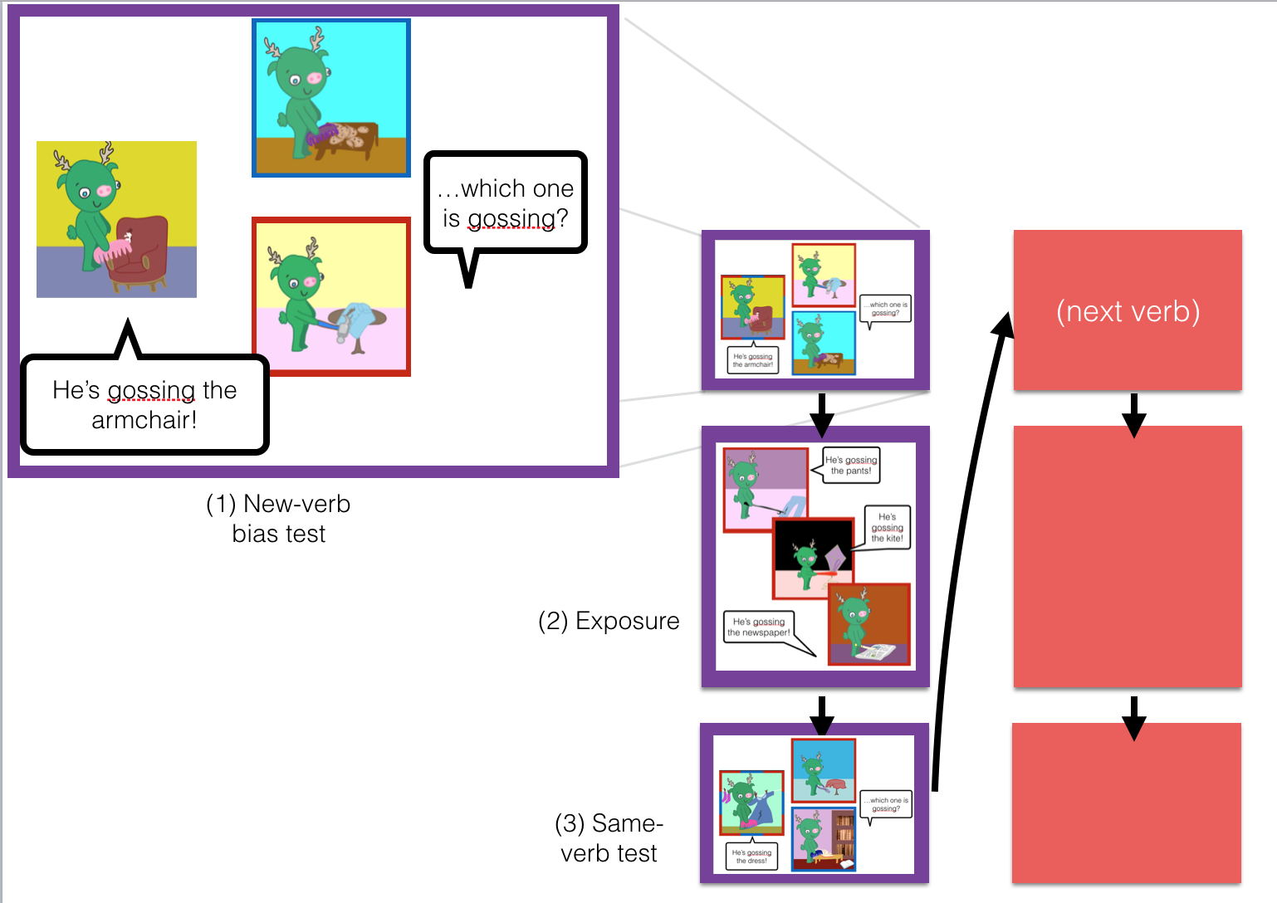

Figure 2: Within- and Across-domain biases: Children who learn Effect verbs develop Effect biases and then maintain a Path bias in the extension phase. (Error bars represent 95% confidence intervals around the mean.)

